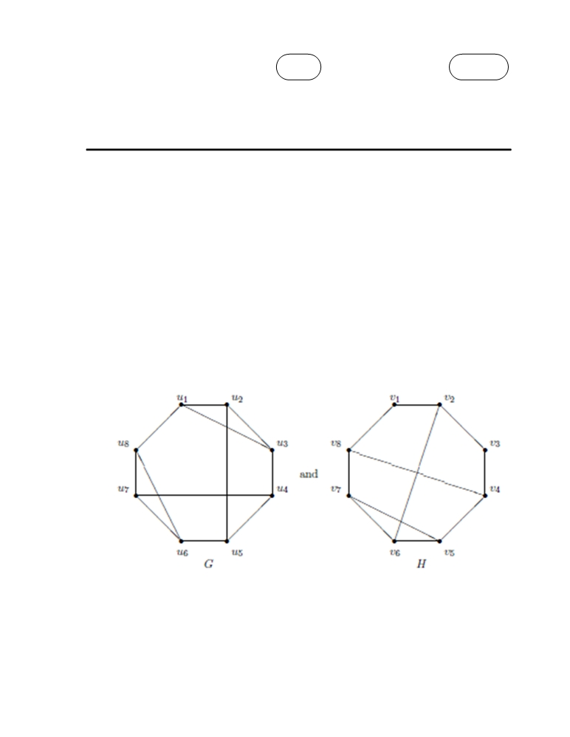

Code No: R21053

R10 SET - 1

II B. Tech I Semester Supplementary Examinations Dec - 2013

MATHEMATICAL FOUNDATIONS OF COMPUTER SCIENCE AND ENGINEERING

(Com. to CSE, IT, ECC)

Time: 3 hours Max. Marks: 75

Answer any FIVE Questions   
All Questions carry Equal Marks

1. a) Show that ((P  Q)  ┐ (┐P  (┐Q  ┐ R)))  (┐ P  ┐Q)  (┐P  ┐R) is a tautology.

b) Show that (x) (P(x)  Q(x) ==>(x) P(x)  ( x) Q(x)

2. a) Apply the Euclidean Algorithm to find gcd {2076,1024}.

b) Discuss in detail about the Principle of mathematical induction.

3. a) On the set Z+ , a relation R is defined by i) Rb if and only if a divides ii) Prove that R is

reflexive, transitive and anti-symmetric but not symmetric.

b) Explain in detail about recursive and Permutation functions

4. a) Define graph. Let G be a non directed graph of order 9 such that each vertex has degree 5 or

6. Prove that at least 5 vertices have degree 6 or at least 6 vertices have degree 5.

b) Determine the following graphs isomorphic or not? Justify your answer.

1 of 2

|''|'||||''|''||'|'|

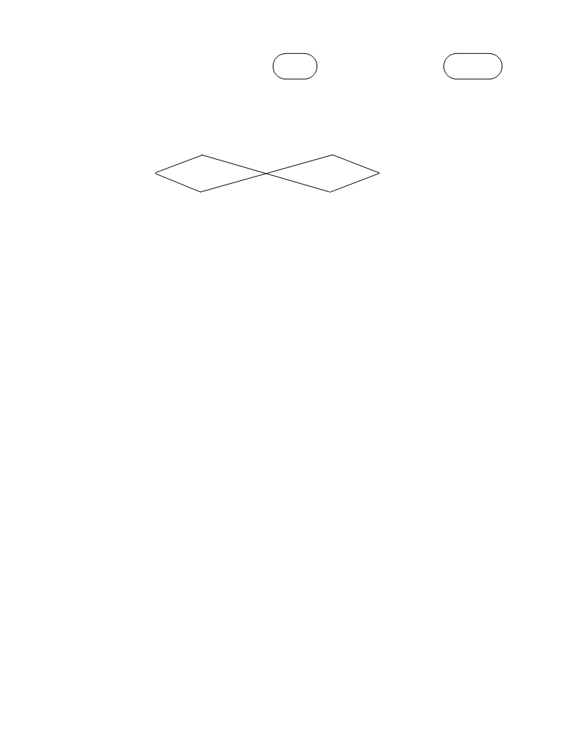

Code No: R21053

R10 SET - 1

5. a) What is a planar graph? Show that any graph with 4 or fewer vertices is planar.

b) Find DFS and BFS for the spanning trees below.

b e

a d f

c g

6. a) Show that every cyclic group of order n is isomorphic to the group < Zn, +n>.

b) “The ring of even integers is a subring of the ring of integers.” Explain.

7. a)Use the principle of inclusion-exclusion to determine the number of prime integers less than   
 400.

b) Use the multinomial theorem to expand (x1+x2+x3+x4)4.

r

8. a) Write the generating function for the sequence  ar 0r defined by ar  (r  2)(r  1)3

b) Find the co-efficient of X50 in (X10+X11+…+X25) (X+X2+…+X15) (X20+X21+…+X45)

2 of 2

|''|'||||''|''||'|'|

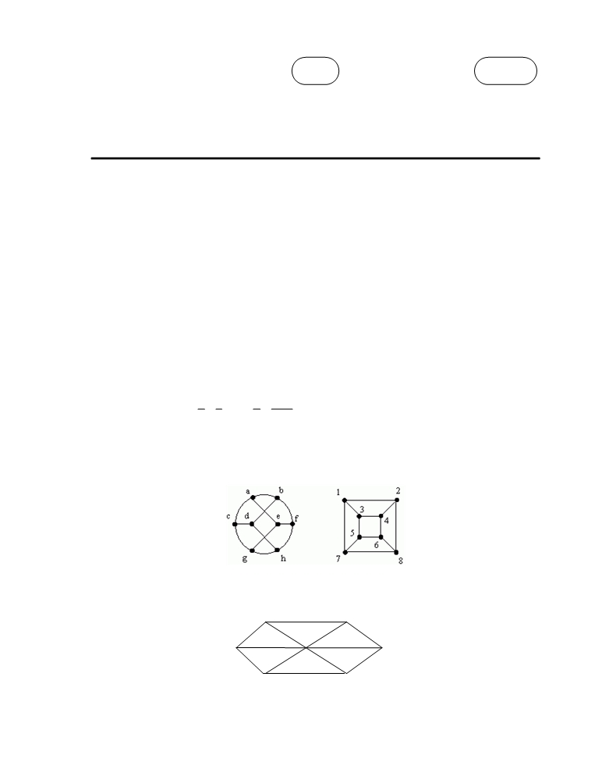

Code No: R21053

R10 SET - 2

II B. Tech I Semester Supplementary Examinations Dec - 2013

MATHEMATICAL FOUNDATIONS OF COMPUTER SCIENCE AND ENGINEERING

(Com. to CSE, IT, ECC)

Time: 3 hours Max. Marks: 75

Answer any FIVE Questions   
All Questions carry Equal Marks

1. a)Obtain the principal disjunctive and conjunctive normal forms of the following

P  (┐P (Q  (┐Q R)))

b) Derive the following using rule CP if necessary

P (Q R), Q (R S) ==> P (Q S)

2. a) With an example describe about testing for prime numbers in detail.

b) Show that 32n+1 +2n-1is a multiple of 7.

3. a) Let A={1,2,3,4} and R={(1,1),(1,2),(2,3),(3,4)}, S={(3,1),(4,4),(2,4),(1,4)} be relations on

A. Determine the relation R S,S R R2and S2. Write down their matrices.

b) Obtain the recursive function for the function f(n)= an in

an  1 

1 1 1 1

   ⋯   

2 3 n n  1

4. a) How many different Hamiltonian cycles are there in Kn , a complete graph on n vertices?

b) Show whether these are isomorphic graphs or not.

5. a) Prove or disprove: If G is a connected graph such that |E|=3|V|-6, then G is planar. Explain.

b) Find the chromatic number for the following graph

A D

B C

1 of 2

|''|'||||''|''||'|'|



Code No: R21053

R10 SET - 2

6. a) Let S= {a,b,c}. Draw the diagram of < ρ(S),  ).

b) Show that the set N of natural numbers is a semi group under the operation z \* y= max{x,y}.   
 Is it a monoid?

7. a) Three Americans, three Mexicans, three Canadians are to be seated in a row. How many   
 ways can they be seated so that,

i) no 3 countrymen sit together?

ii) no 2 countrymen may sit together?

b) How many integers from 1 to 106 inclusive are neither perfect squares, perfect cubes, nor   
 perfect fourth powers?

8. a) How many ways are there to paint 20 identical rooms in a hotel with 5 colors of there is only   
 enough blue, pink and green paint to paint 3 rooms.

b) Solve the following recurrence relations using the characteristic roots   
 6an-19an-1+15an-2=0 where a0=0 and a1= -1/6

2 of 2

|''|'||||''|''||'|'|



Code No: R21053

R10 SET - 3

II B. Tech I Semester Supplementary Examinations Dec - 2013

MATHEMATICAL FOUNDATIONS OF COMPUTER SCIENCE AND ENGINEERING

(Com. to CSE, IT, ECC)

Time: 3 hours Max. Marks: 75

Answer any FIVE Questions

All Questions carry Equal Marks

1. a) Give the truth values of P and Q as T and those of R and S as F, find the truth values of

(┐(P  Q)  ┐R)  (((┐P  Q)  ┐R)  S)

b) Without constructing a truth table, show that A  E is not a valid consequence of

A ← B B← (C  D) C← ( A  E) A  E

Also show that A  C is not a valid consequence of

A ← (B C) B← (┐A  ┐C ) C← (A  ┐B) B

2. a) State and explain about Fermat’s theorem and Euler’s theorem.

b) Discuss in detail about finding least common multiples by prime factorization.

3. a) Let A= {1,2,3,4,6,12}. On A, define the relation R by i) Rb if and only if a divides ii) Prove

that R is a partial order on A. Draw the Hasse diagram for this relation.

b) Discuss in detail about the principle of inclusion and exclusion.

4. a) Discuss in detail about the rules for constructing Hamiltonian paths and cycles with an

example.

b) What is the largest possibility number of vertices in a graph with 35 edges and all vertices of   
 degree at least 3?

5. a) What is the chromatic number of a i) Cycle ii) Tree iii) wheel graph

b) Verify the graph is planar or not

A D

F

E

B C

6. a) If < G,\*> is an abelian group, then for all a, bG. Show that (a\*b)n=an  \* bn

b) Discuss in detail about the properties of Lattices.

1 of 2

|''|'||||''|''||'|'|



Code No: R21053

R10 SET - 3

7. a) State and prove Binomial theorem. Use binomial theorem to prove

 n   n   n   n  n  n

           .(1)    0

 0   1   2  3  n

b) There are 21 consonants and 5 vowels in the English alphabet. Consider only 8-letter words

with 3 different vowels and 5 different consonants.

i) How many begin with b and end with c?   
ii) How many contain the letters a, b and c?

8. a) Find the co-efficient of X16 in (1+X4+X8)10.

b) Write a generating function for an, the number of ways of obtaining the sum n when tossing   
 9 distinguishable dice. Then find a25.

2 of 2

|''|'||||''|''||'|'|

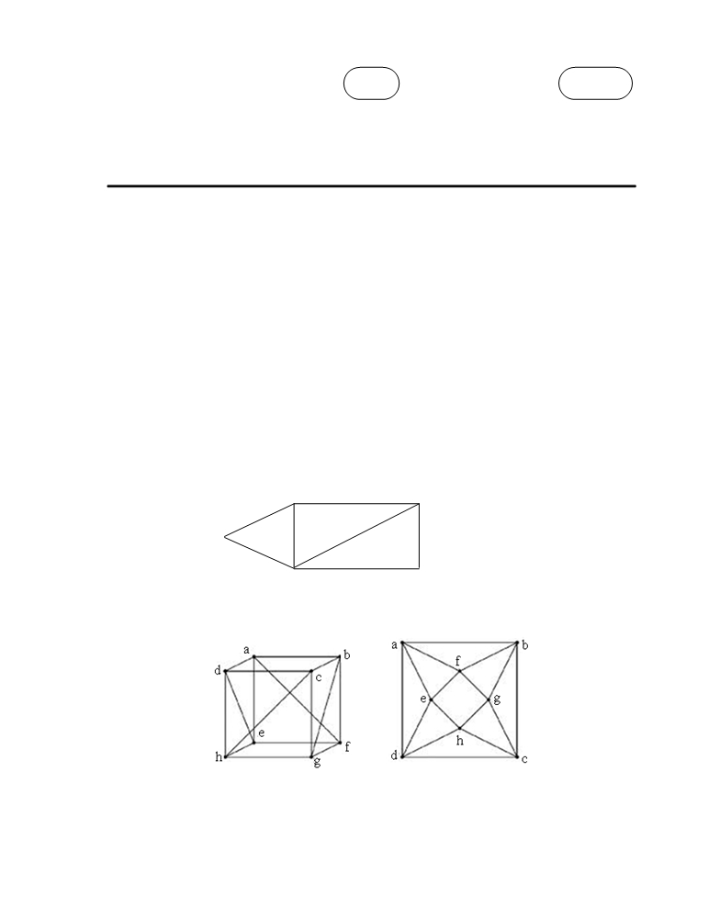

Code No: R21053

R10 SET - 4

II B. Tech I Semester Supplementary Examinations Dec - 2013

MATHEMATICAL FOUNDATIONS OF COMPUTER SCIENCE AND ENGINEERING

(Com. to CSE, IT, ECC)

Time: 3 hours Max. Marks: 75

Answer any FIVE Questions   
All Questions carry Equal Marks

1. a)Show the following equivalences   
 ┐( P← Q) (P  ┐Q)  (┐P  Q)

b) Show that S  R tautologically implied by (P  Q)  (P R)  (Q S)

2. a) Describe in detail about properties of integers. Describe about Division Theorem.

b) Determine the greatest common divisor of the elements of the set {n13-n| nZ}

3. a) Draw the Hasse diagram for the poset (A,  ), where A denotes the power set of the set   
 {a,b,c}.

b) Define Compatibility relation. Explain with an example.

4. a) Find the Euler circuit for the following graph if exists

P e4 Q

e1

T e3 e5 e7

e2

S e6 R

b) Justify why these graphs are isomorphic

1 of 2

|''|'||||''|''||'|'|



Code No: R21053

R10 SET - 4

5. a) Discuss in detail about Euler’s formulae.

b) Find the minimal spanning tree

12

11

9

8

10

2

1

5

7

4

3

6

6. a) Show that every monoid < M,\*,e> is isomorphic to a submonoid of <MM,o,  > where  is   
 the identity mapping of M.

b) Show that in a lattice if a≤ b and c ≤ d then a \* c ≤ b \* d

7. a) How many ways are there to arrange a deck of 52 cards with no adjacent hearts.

b) State the principle of inclusion-Exclusion. Use the principle of inclusion exclusion to count   
 the number of primes between 41 and 100 inclusive.

8. a)Use partial fractions to compute

1  7 X  3

( 1  3 X )( 1  2 X

2

X

)( 1  X )

b) Solve the recurrence relations using generating functions

an-10 an-1+33 an-2-36an-3=0 for n≥3 and a0=1,a1=1 and a2= -23.

2 of 2

|''|'||||''|''||'|'|